GAME DESIGN DOCUMENT

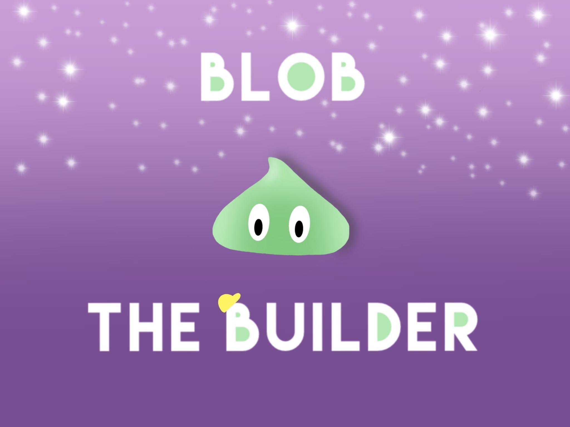

Team: Megan Chua, Kosuke Takahashi, Aaron Seng, Reian Festejo

Contents

|  |  |  |
| --- | --- | --- |
| [1 Game Overview](https://n-xovwktmtjsnaxyc2mwes2xu7pohqedmdm6zjw5q-2lu-script.googleusercontent.com/userCodeAppPanel)  [2 High Concept](https://n-xovwktmtjsnaxyc2mwes2xu7pohqedmdm6zjw5q-2lu-script.googleusercontent.com/userCodeAppPanel)  [3 Unique Selling Points](https://n-xovwktmtjsnaxyc2mwes2xu7pohqedmdm6zjw5q-2lu-script.googleusercontent.com/userCodeAppPanel)  [4 Competitors](https://n-xovwktmtjsnaxyc2mwes2xu7pohqedmdm6zjw5q-2lu-script.googleusercontent.com/userCodeAppPanel) / Similar Titles  5 [Synopsis](https://n-xovwktmtjsnaxyc2mwes2xu7pohqedmdm6zjw5q-2lu-script.googleusercontent.com/userCodeAppPanel)  [6 Game Objectives](https://n-xovwktmtjsnaxyc2mwes2xu7pohqedmdm6zjw5q-2lu-script.googleusercontent.com/userCodeAppPanel)  [7 Game Rules](https://n-xovwktmtjsnaxyc2mwes2xu7pohqedmdm6zjw5q-2lu-script.googleusercontent.com/userCodeAppPanel)  [8 Game Structure](https://n-xovwktmtjsnaxyc2mwes2xu7pohqedmdm6zjw5q-2lu-script.googleusercontent.com/userCodeAppPanel)  [9 Game Play](https://n-xovwktmtjsnaxyc2mwes2xu7pohqedmdm6zjw5q-2lu-script.googleusercontent.com/userCodeAppPanel)  [10 Players](https://n-xovwktmtjsnaxyc2mwes2xu7pohqedmdm6zjw5q-2lu-script.googleusercontent.com/userCodeAppPanel)  [10.1 Characters](https://n-xovwktmtjsnaxyc2mwes2xu7pohqedmdm6zjw5q-2lu-script.googleusercontent.com/userCodeAppPanel)  [10.2 States](https://n-xovwktmtjsnaxyc2mwes2xu7pohqedmdm6zjw5q-2lu-script.googleusercontent.com/userCodeAppPanel)  [11 NPC](https://n-xovwktmtjsnaxyc2mwes2xu7pohqedmdm6zjw5q-2lu-script.googleusercontent.com/userCodeAppPanel) Enemies  [12 Art](https://n-xovwktmtjsnaxyc2mwes2xu7pohqedmdm6zjw5q-2lu-script.googleusercontent.com/userCodeAppPanel)  [12.1 Setting](https://n-xovwktmtjsnaxyc2mwes2xu7pohqedmdm6zjw5q-2lu-script.googleusercontent.com/userCodeAppPanel)  [12.2 Level Design](https://n-xovwktmtjsnaxyc2mwes2xu7pohqedmdm6zjw5q-2lu-script.googleusercontent.com/userCodeAppPanel)  [12.3 Audio](https://n-xovwktmtjsnaxyc2mwes2xu7pohqedmdm6zjw5q-2lu-script.googleusercontent.com/userCodeAppPanel)  [13 Wish List](https://n-xovwktmtjsnaxyc2mwes2xu7pohqedmdm6zjw5q-2lu-script.googleusercontent.com/userCodeAppPanel)  14 Bibliography   |  | | --- | |  | | Game Development Team Members    PRODUCER  Kosuke Takahashi  PRODUCTION MANAGER  Megan Chua    PRODUCTION COORDINATOR  Reian Festejo & Aaron Seng  GAME DESIGNERS  Megan Chua, Reian Festejo, Aaron Seng, Kosuke Takahashi  SYSTEMS/IT COORDINATOR  Reian Festejo & Kosuke Takahashi  PROGRAMMERS  Megan Chua & Kosuke Takahashi  TECHNICAL ARTISTS  Aaron Seng  AUDIO ENGINEERS  Reian Festejo  UX TESTERS  Megan Chua & Aaron Seng |

|  |
| --- |
|  |

# 1 Game Overview

**Title**: Blob the Builder

**Platform**: PC Standalone

**Genre**: 3D Game, Fantasy, Side-Scroller

**Rating**: (10+) ESRB

**Target**: Casual gamer (aging from 12 - 30)

**Release date:** November 2019

**Publisher**: Thunder Thigh Games

Blob the Builder is a fantasy, third person side-scroller game where the Player is a mystical blob that is in a brick structure trying to collect building blocks. The Player must dodge the moving lava structures as they stand in the way. Also, there are bumps that the Player must jump over in order to collect the building blocks. Unfortunately, not all building blocks are great as there is a mysterious, partially transparent building block that will hinder the process. Survive for 30 seconds and collect as many building blocks as you can.

# 2 High Concept

Blob the Builder the Player in a post-apocalyptic future where living organisms have evolved into plasma. Blob the Builder may or may not be a direct descendant of the world renowned builder who carries a similar name. Nonetheless, Blob has a need and want to build for the good of humanity and to bring peace to the world. To achieve this goal, Blob must collect all the proper items to build Happiness. But there are obstacles in his way that will make that process difficult. Collect as many building blocks as possible to ultimately build Happiness.

# 3 Unique Selling Points

* Colorful and unique artwork
* Easy to play, but difficult to master
* Countdown Mechanic
* Endless fun

# 4 Competitors / Similar Titles

Whack-a-mole

# 5 Synopsis

The world is now a mess where the direct descendants of human beings are now blobs. Blob the Builder is one of the descendants of human beings and would like to restore the world back to what it once was. Blob the Builder is in a brick structure and needs to collect as many good building blocks as possible to build Happiness. Happiness is Blob’s secret project to return the world back to normal where life does not seem like a post apocalyptic nightmare. Avoid the moving Lava walls and fake building block and survive for 30 seconds!

# 

# 6 Game Objectives

The objective of the game is to survive for the 30 seconds that is alloted and collect as many building blocks as possible.

# 7 Game Rules

The Player can jump over the bumps that are created, but it must avoid the Lava walls that are running on those bumps. To increase the score, the Player must collect the good building blocks, those being the green and magenta ones. The translucent purple building blocks is a fake building block and will decrease the overall score of the game.

There is a spawning system that is implemented in this game so the building blocks will spawn at random in one of the 10 different spawn points every 1.5 seconds, then disappear every 3 seconds.

# 8 Game Structure

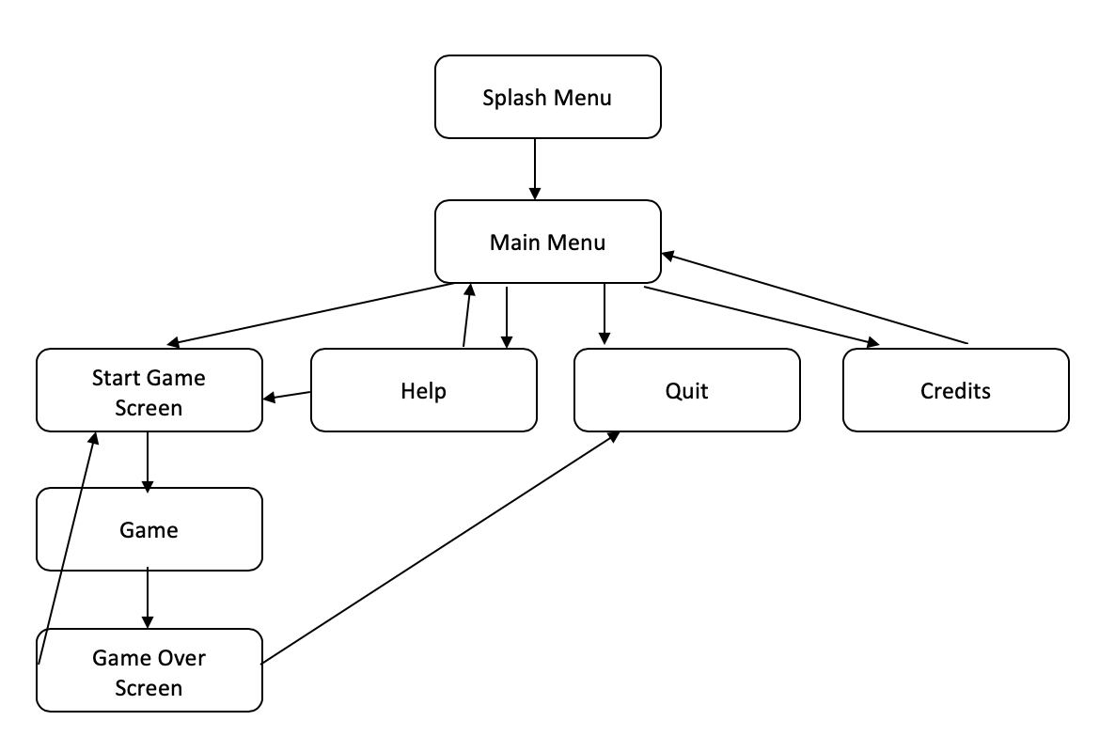

# 

# 9 Gameplay

Game Controls: Use “Space” button to make the blob jump. Use the “a” key to rotate left and the “d” key to rotate right and the “w” key to move in the direction that the blob is facing.

# 10 Players

**Blob the Builder**: Blob is a green blob that has one job and that is to collect all the building blocks to build his secret project that will help end the current world that it lives in and return the world back to happiness and peace.

**Metrics:**

*Speed*: 5

*Jump*: 10

*Rotation Speed*: 400

**Player State:**

*Idle*:

The idle state has an animation where the blob moves the tip of his head and it is triggered when

the Player stops moving.

*Move*:

The move state has an animation where the whole blob jiggles its body around to signal that it is

moving. This is triggered when the Player is moving on the ground.

*Jump*:

The jump state has an animation where the blob grows and point up to signify a jump. This is

triggered when the Player jumps.

# 11 NPC

The Lava Blocks constantly move on the path that it is assigned and nothing can slow it down. When the blob touches the lava block, then it dies.

The building blocks spawn on 10 set spawn points throughout the level. When the blob touches the block, the score will change accordingly.

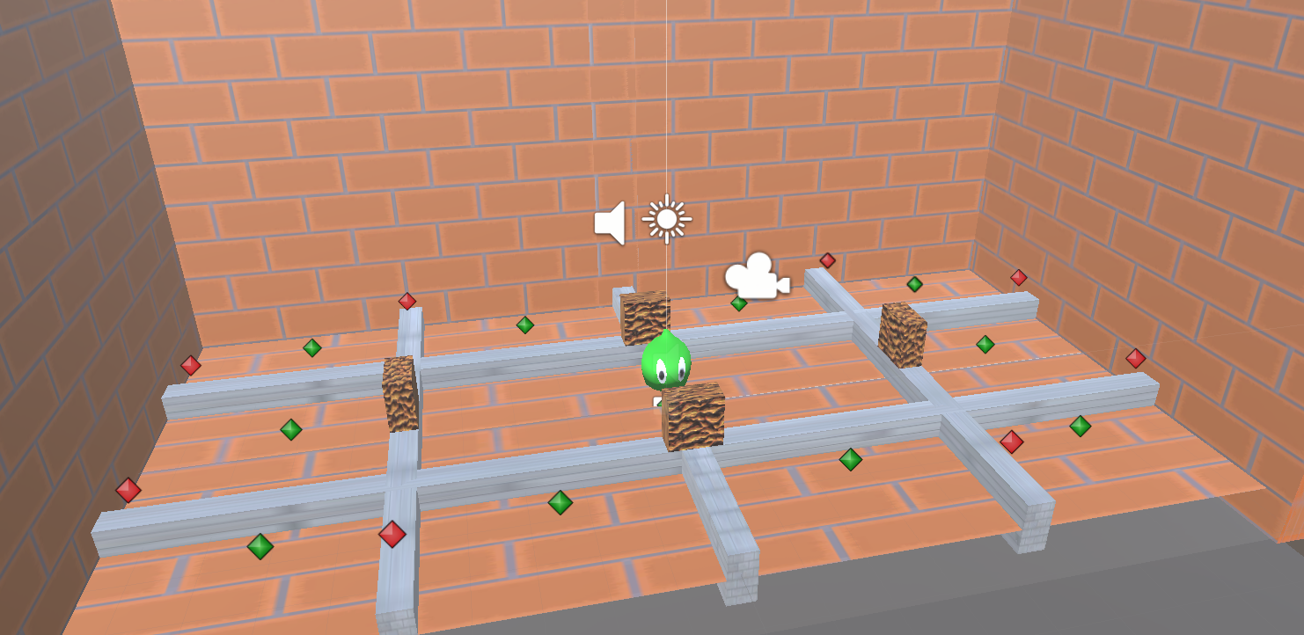

|  |  |  |
| --- | --- | --- |
| Name | Speed | Effect |
| Lava Block | 10 | Kills on impact |

Building Blocks:

|  |  |  |
| --- | --- | --- |
| Type of Block | Spawn Rate | Effect |
| Really Good Block (Magenta) | 20% | Adds 3 points to the score |
| Regular Block (Green) | 50% | Adds 1 point to the score |
| Bad Block (Translucent Purple) | 30% | Subtracts 1 point to the score |

# 12 Art

**Character:**

Blob the builder was made as a 3D model in Blender.

**Setting:**

The game takes place in a brick structure with lava blocks roaming around.

**Level Design:**

The level occurs inside of a rectangular room with little bumps on the floor and 2 bumps that move up and down during gameplay.

**Audio:**

|  |  |
| --- | --- |
| Name | Description |
| Blob the Builder | Plays while the main menu is open |
| death | Plays when the player dies |
| gameplay | Plays as background music during gameplay |
| jump | Plays when the player jumps |

# 13 Wish List

* Add more obstacles to have an increasing difficulty over time
* Create a more open world map so Blob the Builder can travel farther and look for more building blocks
* Add more metric growth for the Player, like growth or speed increases

# 14 Bibliography

“Blazer Rail - Royalty Free Music.” *DL Sounds*, 30 Sept. 2019, https://www.dl-sounds.com/royalty-free/blazer-rail/.

BornCG. “Blender 2.7 Tutorial #66: Cartoon Eyes Rig #b3d.” *YouTube*, 22 Oct. 2016, https://youtu.be/kB9cJ3wOoPk.

Dklon. “Platformer Jumping Sounds.” *OpenGameArt.org*, OpenGameArt.org, 12 June 2013, https://opengameart.org/content/platformer-jumping-sounds.

gh, kinan. “Unity 5 How to Make Objects Follow a Path|| KinanGh.” *YouTube*, Kinan Gh, 20 Nov. 2016, https://youtu.be/fKWTpi70a_E.

Lowlypoly. “Stylized Lava Texture.” *Asset Store*, https://assetstore.unity.com/packages/2d/textures-materials/stylized-lava-texture-153161.

Nevlext. “15 Original Bricks Textures.” *Asset Store*, https://assetstore.unity.com/packages/2d/textures-materials/brick/15-original-bricks-textures-72427.

“shot_player.” *Pixelnest.io*, Pixelnest, https://pixelnest.io/tutorials/2d-game-unity/sounds/-sounds/shot_player.wav.

Single Sapling Games. “Countdown Timer In Unity - Easy Beginners Tutorial/ Guide.” *YouTube*, Single Sapling Games, 1 July 2018, Countdown Timer In Unity - Easy Beginners Tutorial/ Guide.

xOctoManx. “Unity 5 Tutorial: Spawn Random Objects at Random Positions C#.” *YouTube*, XOctoManx, 10 May 2015, https://youtu.be/iLTP4EbM1N4.